**CODING ASSESSMENT – AZURE DEVOPS**

**Implement any one of CICD pipeline activity in Azure DevOps.**

**Step-by-Step Guide: CI/CD Pipeline in Azure DevOps**

**Step 1: Create an Azure DevOps Project**

1. Navigate to [Azure DevOps](https://dev.azure.com/).

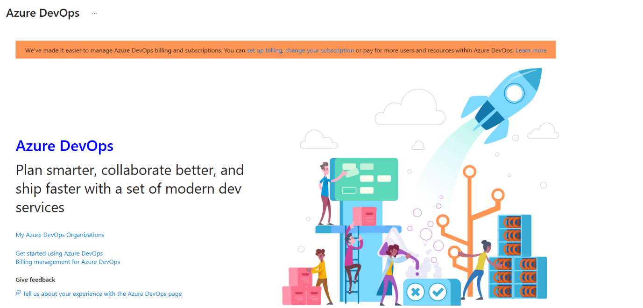

Click My Azure DevOps Organizations.

1. Create a **New Project** — SecuredBanking-CICD.

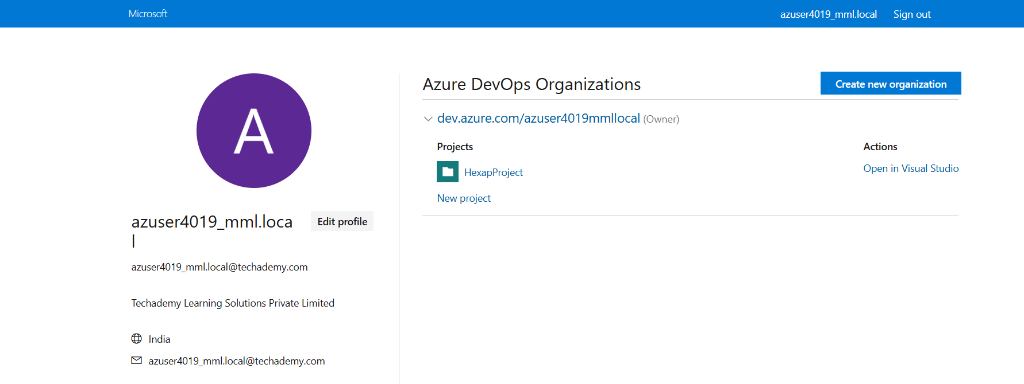

1. Set visibility (private), then click **Create**.

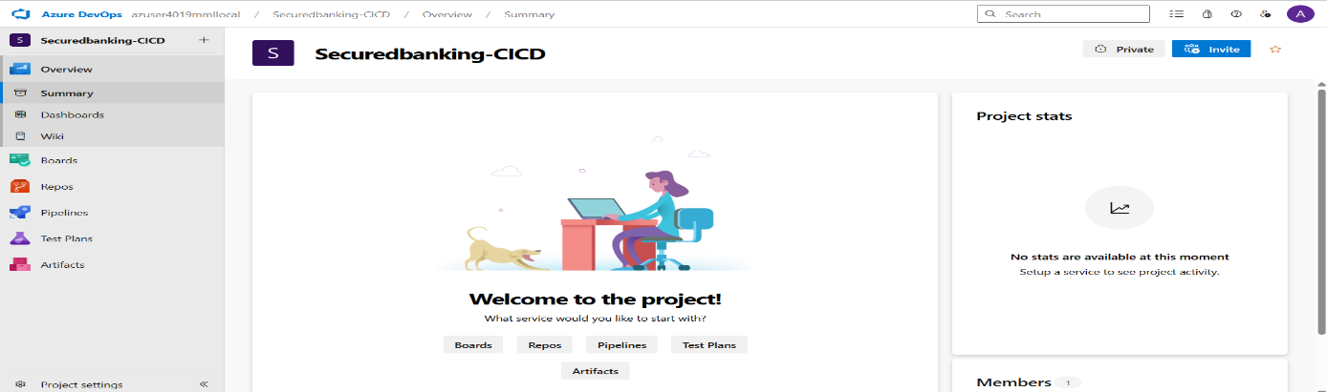

**Step 2: Connect Your GitHub Repo**

1. In Azure DevOps, go to **Pipelines → Create Pipeline**.

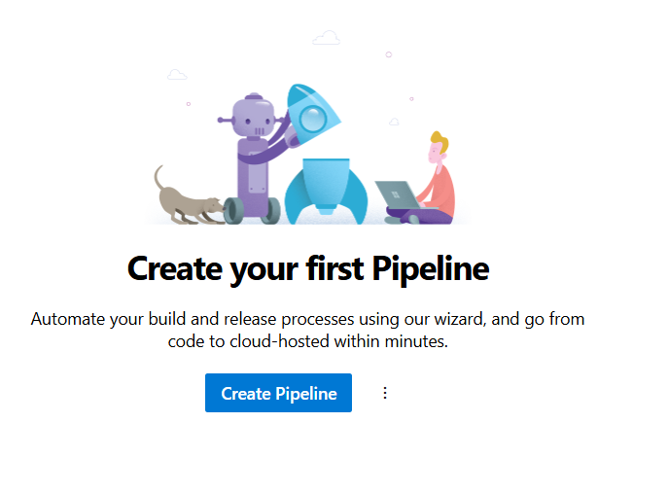

1. Choose **GitHub** and authorize Azure DevOps access.

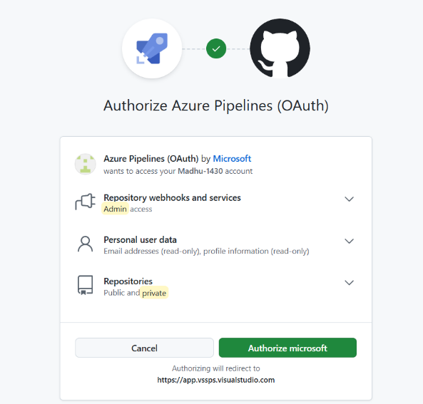

1. Select your repo: Madhu-1430/Project-CICD.

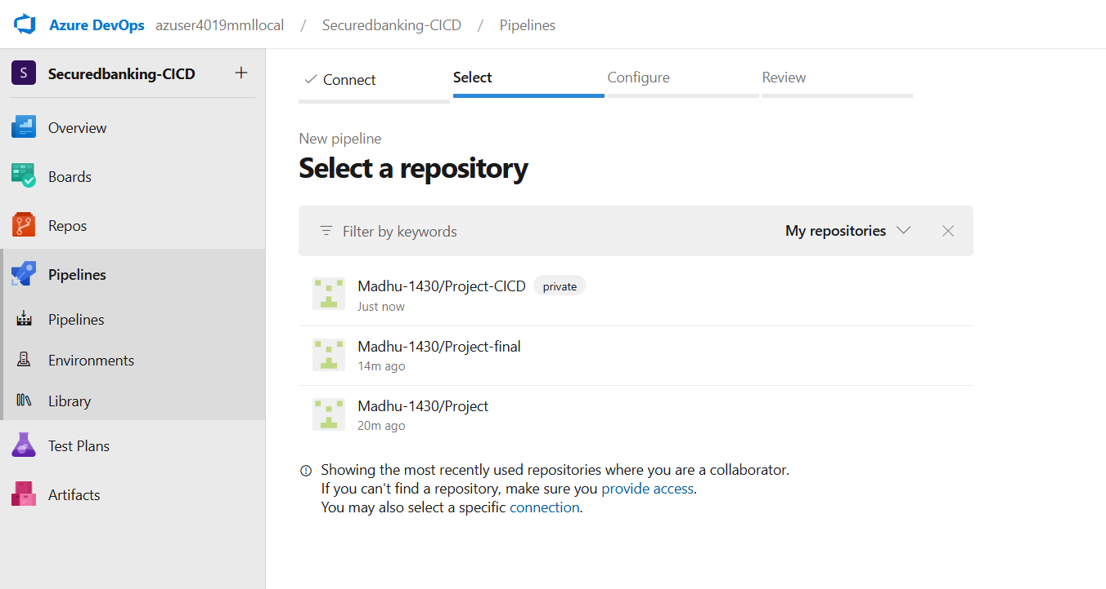

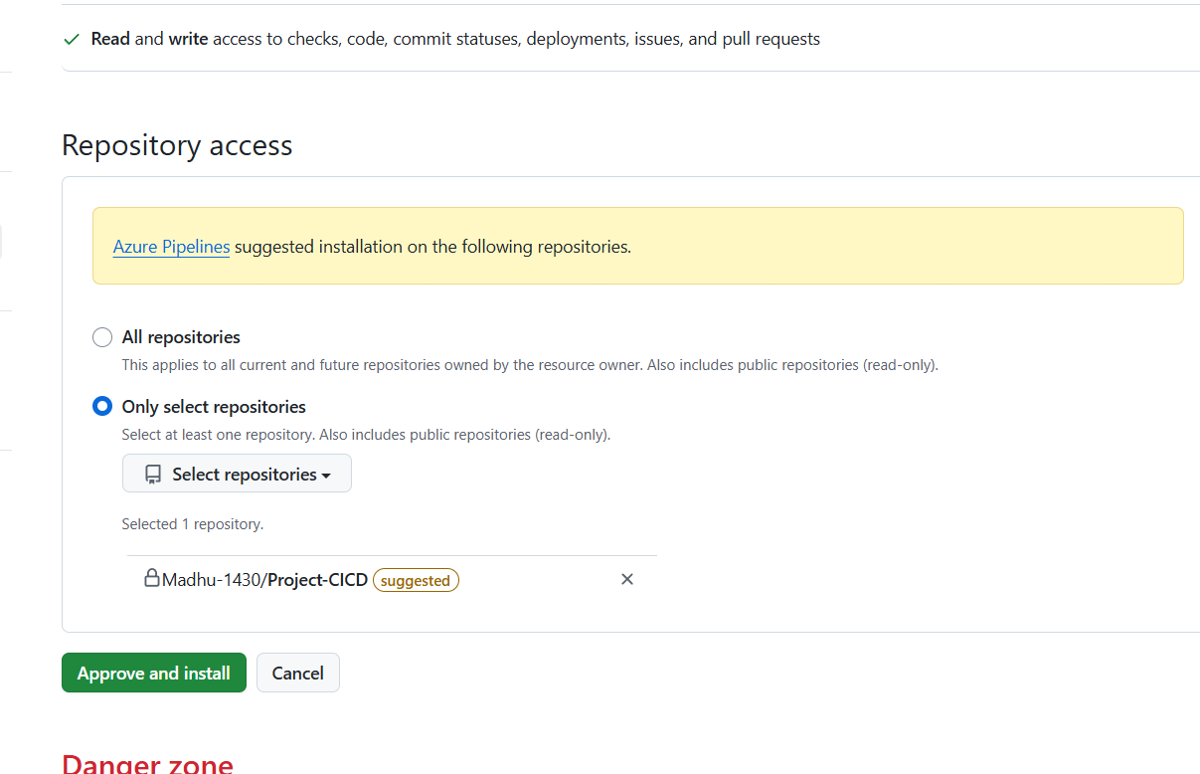

Click Approve and install.

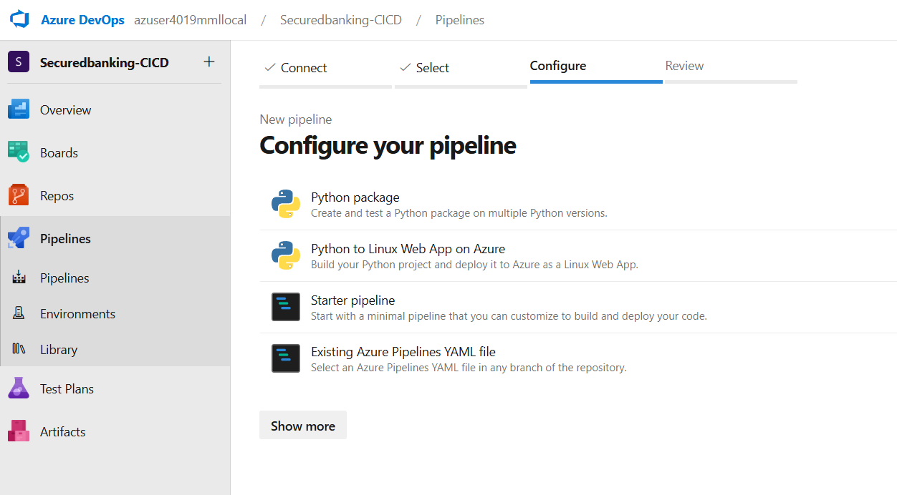

Select the Starter pipeline and edit the code with the below code .

**Step 3: Define the Pipeline (YAML)**

Azure DevOps will offer a starter YAML. Replace it with this template tailored for your project:

trigger:

- main # Trigger pipeline on pushes to main branch

pool:

vmImage: 'ubuntu-latest'

steps:

# 1. Set up Python

- task: UsePythonVersion@0

inputs:

versionSpec: '3.x'

# 2. Install dependencies if needed (create requirements.txt or list them)

- script: |

python -m pip install --upgrade pip

# Uncomment next line if you have requirements.txt

# pip install -r requirements.txt

displayName: 'Install dependencies'

# 3. Run your application as a smoke test

- script: |

echo "Running app.py for smoke test..."

python app.py --help || true

displayName: 'Smoke test (no deployment)'

# 4. Publish build artifact (your source files)

- task: PublishBuildArtifacts@1

inputs:

PathtoPublish: '$(System.DefaultWorkingDirectory)'

ArtifactName: 'source-code'

publishLocation: 'Container'

**What It Does:**

* Executes on every push to main.
* Sets up Python 3.x.
* Installs dependencies (if you add a requirements.txt).
* Runs a basic check by executing app.py.
* Publishes your repo as an artifact in Azure DevOps.

**Step 4: Save & Run**

1. Click **Save and Run**.
2. Commit the pipeline YAML to your repo .
3. The pipeline will trigger and show logs for each step.

